Middle/High School Sunday School Lessons by

rfour.org

Year 4: Session 3 – The Israelites and the Wilderness
Class 7: Numbers 13:32-33, 14:1-11, 26-33, 39-45 – No Promised Land

CONCEPTS that will be covered in the lesson
- Read and discuss the story of the Israelites messing up their first entry into the promised land
- Explore the concepts of immaturity, lack of trust and fear of failure as a way to help understand the Israelites’ choices

Materials needed:
- Movie clip (available on rfour.org) from Mighty Ducks
- Electronics that show the video clip
- For activity
  - 3 soft/foam balls or beanbags (in a pinch, balled-up paper works, too) per team.
  - 1 Blindfold per team
  - 1 Stopwatch
  - Masking tape (or rope) to mark where students will stand
  - 1 empty box per team (like a copy paper box or similar size)

THE LESSON

OPENING PRAYER

OPENING QUESTION
- One of the things we do every class is ask and answer the opening question at the beginning of class – because it helps us 1. Learn more about each other and 2. Helps “warm us up” for some of the ideas in the upcoming lesson. So we’re going to do that now.
- So here’s the opening question for today’s class. I [the teacher] will ask the question and then to give you some time to think of an answer, I will answer first.
- Once I answer the question, we’ll go around the circle and each of us will answer.
- When it’s your turn, start with your name and then answer the question to the best of your ability.
- Here’s this week’s question: What is something you think you understand but your parent or grandparent does not understand?

INTRO
- Today is the last class of our session about the Israelites in the wilderness.
- What we’ve mostly seen is that the Israelites are having a hard time with freedom and they have a hard time trusting God since they left Egypt.
- In last class’ story, we saw how the people’s lack of trust was weighing heavily on Moses
- In today’s story, there’s a lot that happens, but ultimately, what we see is that the Israelites still don’t haven’t learned that their lack of trust in God leads to dead-ends

TRANSITION TO VIDEO
- To help us think about why the people do what they do in the story, we’re going to focus on trust (or the lack of it) and maturity (or the lack of it)
- So, to begin with, let’s watch the following movie clip from the 1995 movie (look at the “mobile” phone the coach uses!), The Mighty Ducks
- This is a typical sports movie with kids where the original team is not very good at what they do and the coach is flawed
- But together they will learn from each other and succeed beyond their wildest dreams!
- Sound familiar?
- In this clip, the flawed coach and the not very good hockey team meet for the first time.
- Let’s see what happens

WATCH MOVIE CLIP

ASK
- So, do the team and coach respect or trust each other at first? (not at all)
- Do you think that will change as they get to know each other? (probably)
- What does the coach eventually tell them to do? (play 4 on 4)
- Does the team listen? (briefly)
- What does the team do after the coach gets in the car (they briefly do what they’re told and then they jump on the car and invade the car)
- What does the team convince the coach to do? (drive the car around on the ice)
- So what do you think, are they are ready to play in a big, important championship game at this point in the movie? (no)

TRANSITION to Scripture Story
- Today’s story takes place probably 9 to 12 months after the Israelites’ left Egypt.
- And, it marks their arrival to the land of their ancestors (Abraham, Isaac, and Jacob – whose name was changed to Israel)
- If we look at a map of their journey, we see that the Israelites did not take a direct line to the land that God is promising them

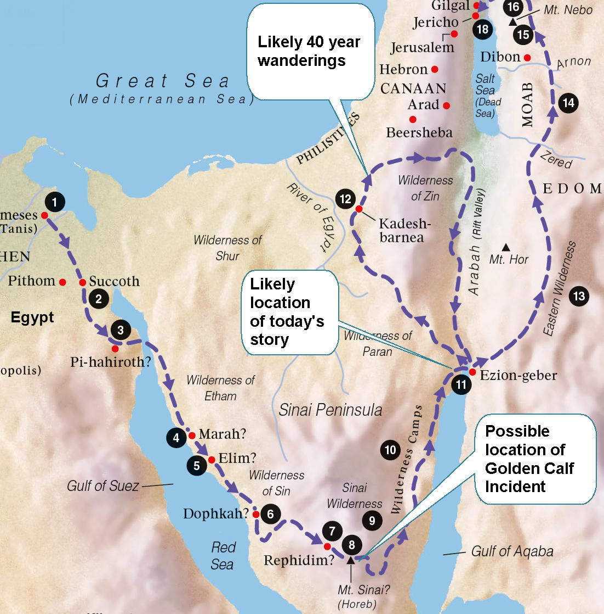

- Most likely, this is because God wants the Israelites to have some time to learn how to trust Moses and God.
- So, the Israelites arriving at the promised land SHOULD be a big deal for them
- After 400 years of slavery to the Egyptians and in much greater numbers, the now very large family of Israel has returned to the land that God had told Abraham would be his home
- However, other people live in the land
- And, because they are afraid of these other people, the Israelites send spies, one spy per tribe, into the land to check out the land and the people who are living there
- This was not a God-instructed action – to send spies
- Today’s story begins with the spies giving their reports to the Israelites
- Let’s see what happens

READ Numbers 13:32-33, 14:1-11, 22-33, 39-45 (recommend class reads it out loud; one person per verse)

Numbers 13:32-33
32 So they [10 of the 12 spies] brought to the Israelites an unfavorable report of the land that they had spied out, saying, “The land that we have gone through as spies is a land that devours its inhabitants; and all the people that we saw in it are of great size. 33There we saw the Nephilim (the Anakites come from the Nephilim); and to ourselves we seemed like grasshoppers, and so we seemed to them.”

Numbers 14:1-11, 26-33, 39-45
Then all the congregation raised a loud cry, and the people wept that night. 2And all the Israelites complained against Moses and Aaron; the whole congregation said to them, “Would that we had died in the land of Egypt! Or would that we had died in this wilderness! 3Why is the Lord bringing us into this land to fall by the sword? Our wives and our little ones will become booty; would it not be better for us to go back to Egypt?” 4So they said to one another, “Let us choose a captain, and go back to Egypt.”
5Then Moses and Aaron fell on their faces before all the assembly of the congregation of the Israelites. 6And Joshua son of Nun and Caleb son of Jephunneh, who were among those who had spied out the land, tore their clothes 7and said to all the congregation of the Israelites, “The land that we went through as spies is an exceedingly good land. 8If the Lord is pleased with us, he will bring us into this land and give it to us, a land that flows with milk and honey. 9Only, do not rebel against the Lord; and do not fear the people of the land, for they are no more than bread for us; their protection is removed from them, and the Lord is with us; do not fear them.” 10But the whole congregation threatened to stone them. Then the glory of the Lord appeared at the tent of meeting to all the Israelites.

11And the Lord said to Moses, “How long will this people despise me? And how long will they refuse to believe in me, in spite of all the signs that I have done among them?

26And the Lord spoke to Moses and to Aaron, saying: 27How long shall this wicked congregation complain against me? I have heard the complaints of the Israelites, which they complain against me. 28Say to them, “As I live,” says the Lord, “I will do to you the very things I heard you say: 29your dead bodies shall fall in this very wilderness; and of all your number, included in the census, from twenty years old and upward, who have complained against me, 30not one of you shall come into the land in which I swore to settle you, except Caleb son of Jephunneh and Joshua son of Nun. 31But your little ones, who you said would become booty, I will bring in, and they shall know the land that you have despised. 32But as for you, your dead bodies shall fall in this wilderness. 33And your children shall be shepherds in the wilderness for forty years, and shall suffer for your faithlessness, until the last of your dead bodies lies in the wilderness.

39When Moses told these words to all the Israelites, the people mourned greatly. 40They rose early in the morning and went up to the heights of the hill country, saying, “Here we are. We will go up to the place that the Lord has promised, for we have sinned.” 41But Moses said, “Why do you continue to transgress the command of the Lord? That will not succeed. 42Do not go up, for the Lord is not with you; do not let yourselves be struck down before your enemies. 43For the Amalekites and the Canaanites will confront you there, and you shall fall by the sword; because you have turned back from following the Lord, the Lord will not be with you.” 44But they presumed to go up to the heights of the hill country, even though the ark of the covenant of the Lord, and Moses, had not left the camp. 45Then the Amalekites and the Canaanites who lived in that hill country came down and defeated them, pursuing them as far as Hormah.

ASK
- Is there anything you find interesting or weird about this story? [to teachers: You don’t necessarily need to answer what they notice or have questions about – sometimes just agree with a, “yep, that’s interesting” or a, “Yeah, I find that to be weird, too” works]
- Verse 13:32-33 – What are the spies telling the Israelites? (that the people in the land are big – either in physical size or in number or both – and because of that, they, the Israelites, will be squashed)
- Verse 14:1 – Are the people happy to hear this? (nope)
- Verse 14:2-3 – In their disappointment, what do they do? (they complain. They blame Moses and Aaron and God. They wish they had never left Egypt – sound familiar?)
- Verse 14:4 – What do they propose to do? (fire Moses and return to the land of their oppression)
- Does it sound like the people have learned to trust Moses and/or God, yet? (nope)
- Verse 5&6 – Who are the people who speak against this blaming and complaining? (Hard to say if Moses and Aaron actually do any speaking, but we’ll go with Moses, Aaron, Joshua and Caleb)
- Verse 11 – Does God seem to think the Israelites response is the right kind of response? (No. In fact God seems annoyed and disappointed)
- In verse 2, the Israelites say, “Would [it not have been better] that we had died in this wilderness!?” So what does God give the Israelites in verses 26-33? (God agrees with their request – says, “OK, fine, you think it’s better to die in the wilderness – go die in the wilderness)
- Verse 39 – Are the Israelites happy to get what they asked for? (Nope, not at all. Pretty much seems like whatever God says, they want to do the opposite of it)
- Verse 40 – What is their next plan of action, then? (to go attack the people in the land – note that God never said, “You are to attack the people in the promised land” – this is what the Israelites have assumed would happen)
- Verse 45 – Did their attack work? (Nope, they lost the fight)
TELL
- To help us think about the Israelites’ reaction, let’s review our previous stories
- If we think back to the Golden Calf story and think of the movie clip we watched with that story, then we get a picture of a people who are very new to the idea of freedom. In fact, in receiving freedom, what they do with it, then, is make a big ol’ mess.
- So then in food story (manna and quail) and the Moses’ leadership story, what we see God doing and Moses, too, is try and help the Israelites know and understand how to live into their freedom.
- By the time the Israelites get to the promised land in today’s story, they HAVE grown up a little bit.
- Now, instead of kindergarten kids throwing paint on the walls, they’ve grown into a hockey team – who sorta, kinda listen to their coach, but not really.
- They are kind of rebellious, now.
- They talk back a little bit.
- They make assumptions about what is going on and sometimes, they do the exact opposite of what they are told to do.
- But today’s story is like a championship game
- And, imagine what that hockey team we just saw in the video clip – imagine how they would do if they had to play a big important championship game the next day – with that sort of pressure and stress being applied, their lack of skill, lack of training, and general distrust of the coach would’ve created a great amount of stress in them.
- They would probably get upset because of their fear of imminent failure
- But instead of chanting “We want a ride, hey!,” the Israelites lash out by saying very ungrateful things like “Let’s go back to Egypt” and “It would’ve been better to have died in the wilderness!” and “Let’s replace Moses”
- But here’s the thing: God never told them, “Tomorrow is a championship game.”
  - God never told them, “I’m going to have you fight these people.”
  - And, God never told them, “Send spies into the land.”
- In fact, we never know what God’s plan is for the people because they freak out before they ever get to hear the plan.
- And God, seeing the people freak out, acts like the coach does in the movie clip and realizes that it’s probably best to give in and do what the people want.
- God also seems to know that a lot more time is going to be needed before bringing them back to the promised land aka Canaan.
- So, even though it seems like a punishment to wander for forty years and die in the wilderness, it’s probably the best outcome available for the relationship between the Israelites and God based on where the Israelites are, developmentally, as a people who just left 400 years of captivity.

TRANSITION to ACTIVITY
- So the Israelites didn’t trust God or listen to God about what God was calling them to do
- Because of this lack of trust, they freaked out at what they thought would be imminent failure
- We’re going to do an activity now, where, as a class, we’ll experience the progression of experience that the Israelites will have to go through during their 40 years in the wilderness
- In today’s story, of course, they’re only in the first step/level/type of experience.

EXPLAIN Activity

General Instructions:
- Let’s get into two teams of three to seven people (in our case, that will most likely be one team)
- Each team receives one blindfold, one ball, one box.
- The line of tape (or string) on the floor marks the start line for each team
- Notice that each team’s box is 10 to 15 feet away from each start line.
- Now, each team needs to assign a thrower, a retriever, a scorekeeper, and an assistant. The rest are the wise advice givers (aka Moses, Aaron, Joshua and Caleb)
- There will be three rounds. Each round is one minute long
- There are different rules for each round, but the scoring is always the same:
  - One point is scored for every ball the thrower gets into the box. (The ball can bounce out; as long as it bounces into the goal box first it counts as a point.)
  - The goal is for the thrower to score as many points as possible per round
- For every round, the thrower is blindfolded, and must stand behind the start line at all times.
- For every round, the retriever will pick up the ball and throw it back to the assistant
- For every round, the assistant gives the ball back to the thrower
- For every round, the scorekeeper then adds up the successful tosses for each round.
- Any questions

DO ACTIVITY
Instructions for each round
Round 1:
- No talking.
- The thrower attempts to score as many points as possible with no input or coaching from their team.

Round 2:
- The team can coach their thrower by saying either “yeah!” or “boo!” but nothing else.
- The thrower attempts to score as many points as possible with this limited feedback from their team.

Round 3:
- The team can coach their thrower by providing any helpful information.
- The thrower attempts to score as many points as possible with extensive feedback from their team.

ASK
- What round was the most successful?
- Why?
- What was most challenging for you (the thrower) in Round 1, receiving no feedback? How did you overcome the lack of support?
- Advice givers – what was most challenging for you? (not being heard, probably – OR – not being able to speak in the first two rounds)

TELL
- So that first round – before you’re really working together as a team is how the Israelites were functioning in today’s story.
- They still just aren’t to round 2 or round 3 yet
- Because, even when they did receive instruction, like you did in the third round, they are too worried to hear/trust what’s being told to them
- The idea, of course, is that they’ll learn to work together with each other and with God.
- Even more challenging than this this activity was for us, learning to trust each other and God is even more challenging for the Israelites
- Which is a reminder to us, that our own relationship with God may not be so easy, either.
- It can be a slow and frustrating journey as we try to be in relationship with invisible divinity
- And that’s why it helps to have each other to talk about God and the challenges of getting to know God and being in relationship with God – just like we do in these classes.
- Thanks for the conversation and participation!

CLOSING PRAYER

