Middle/High School Sunday School Lessons by

rfour.org

Year 4: Session 8 – Peter
Class 23: Matthew 16:21-26 – Get Behind Me, Satan

CONCEPTS that will be covered in the lesson
- Establish what is means to order priorities
- Read the story and help unpack the line of “Get behind me, Satan” within the context of priorities
- Highlight how focusing on God helps us better understand and order our other priorities

Materials needed:
- Video clip (available on rfour.org) from The Office (again -- the American-version TV show)
- Electronics that show the video clip
- For the activity
  - Have two sheets of paper, one with a big A on it and one with a big 1 on it
  - Tape each sheet of paper on opposing walls of the classroom
  - Print out one of the brackets located at end of lesson so that you can fill in the priorities and track which one wins

THE LESSON
OPENING PRAYER

OPENING QUESTION
- One of the things we do every class is ask and answer the opening question at the beginning of class – because it helps us 1. Learn more about each other and 2. Helps “warm us up” for some of the ideas in the upcoming lesson. So we’re going to do that now.
- So here’s the opening question for today’s class. I [the teacher] will ask the question and then to give you some time to think of an answer, I will answer first.
- Once I answer the question, we’ll go around the circle and each of us will answer.
- When it’s your turn, start with your name and then answer the question to the best of your ability.
- Here’s this week’s question: What’s something you think isn’t so important that other people seem to think is quite important?

INTRO
- In our last class, we began a new session about Peter, the disciple
- In that first story we read about him, we saw him walk on water and then sink into it because he lost his focus during a chaotic, stressful situation.
- Also in that story, we saw that Jesus was focusing on God and because of his focus on God, he was able to stay clear-minded during a chaotic, stressful situation – in other words, Jesus was able to stay ABOVE the chaotic, stressful situation whereas Peter was not able to.
- Today’s story is really the exact same story as the previous Peter story we read.
- At first, the plot looks different, especially since all that actually happens is that Jesus and Peter have a conversation.
- But in that conversation, we will see (once again) that what Peter is focused on and what Jesus is focused on are not yet in-sync.
- Peter still has some things to learn
- But to get started, we’re going to talk a little bit about “priorities” as a way to help us think about today’s story

EXPLANATION of ACTIVITY
- My guess is that you know what a priority is – so I’ll just ask, what do you think is a priority? (something you think is important)
- Right – and the idea of priorities is that you prioritize them – that is, you put them in order of most important to least important and you make sure the least important priorities do not get in the way of the most important priorities
- To help us think about how difficult it can be just to make a list of priorities (much less follow THROUGH with our priorities), we’re going to create our own “Priorities Madness Bracket”
- As you can see here (show bracket), we have eight already chosen priorities listed in a bracket
- Our activity will be to have a “playoff” (or a “vote-off” if you will) between these pretty standard priorities to see which priority we think is our most important priority
- Here’s how it works: I will call out the two priorities that are competing with each other. One priority will be “A” and the other priority will be “1.”
- You’ll then vote by standing next to the wall with the letter/number that represents the priority that you think is more important
- We’ll then have a bit of discussion between sides (about a minute total – if needed) to see if voters can be swayed to change their votes
  - IMPORTANT: This discussion is meant to invite others to join you in your vote. This discussion time is NOT a chance to shame or make fun of those who are voting differently than you
- Whichever priority gets the most votes will proceed to the next round
- Note: This doesn’t mean we think that the thing getting less votes is not important, we’re just saying it is not AS important as the other priority
- In case of a tie, teacher(s) get to vote too!
- Any questions?

DO ACTIVITY
(Note: The faith/God entry will probably lose. Do not shame the students or force them to reconsider)

List of priorities to put in bracket (in whatever order you want)
- Education
- Family
- Relationships (mentors / friends / significant other)
- Faith / God
- Career / Finances
- Fun (Travel / Entertainment / Hobbies)
- Safety / Health / Fitness
- Helping others

TELL / TRANSITION to SCRIPTURE
- Let’s review the results (list most important priority, second level of priorities, third level, fourth level of priorities based on activity)
- Any thoughts you have about the results that you would like to share?
  - [Teachers: Maybe remark what you noticed how they made their decisions – especially regarding logical ordering in terms of sequence – ie, “best to have a career first and then I can afford to have fun,” etc]
- OK – I want to stress that this is probably NOT the best way to make a list of priorities
- In theory, the idea is that once you DO determine what is most important in life, you would then make decisions based on those priorities – which is even harder than just determining what the priorities are in the first place
- Optional: For example, it’s a Saturday afternoon and you can either go see a movie with friends that you’ve really been wanting to see versus an invitation to hang with family and go shopping (or something like that). In theory, you could just make it a mathematical equation: Does family + a little bit less fun activity rank higher on the priority list than friends + a really fun activity?
- Hopefully, what this activity does is help us think about how difficult it can be to determine what we think is most important in life – and how, at times, not everyone agreed about what was most important.
- In today’s scripture story, we will see Jesus and Peter have a conversation about priorities, sort of like we just did.
- Jesus is probably somewhere between halfway to 2/3rds through his one year ministry (in Matthew, Mark, and Luke, his ministry happens during a one year time span; in John it happens in a three year timespan)
- And, he’s telling the disciples what to expect as his ministry concludes
- That’s when we will see a clash of priorities. Peter has a different top priority than Jesus does.
- In Peter’s defense, Peter’s top priority seems pretty reasonable and Jesus’ response to Peter might seem strange -- so let’s read the story and then talk about it

READ Matthew 16:21-26 (recommend class reads it out loud; one person per verse)

21 From that time on, Jesus began to show his disciples that he must go to Jerusalem and undergo great suffering at the hands of the elders and chief priests and scribes, and be killed, and on the third day be raised. 22And Peter took him aside and began to rebuke him, saying, ‘God forbid it, Lord! This must never happen to you.’ 23But he turned and said to Peter, ‘Get behind me, Satan! You are a stumbling-block to me; for you are setting your mind not on divine things but on human things.’

24 Then Jesus told his disciples, ‘If any want to become my followers, let them deny themselves and take up their cross and follow me. 25For those who want to save their life will lose it, and those who lose their life for my sake will find it. 26For what will it profit them if they gain the whole world but forfeit their life? Or what will they give in return for their life?

ASK
- Verse 21 – What does Jesus tell his disciples is going to happen? (that he’s going to experience great suffering and then be raised on the third day)
- Do you think the “raised on the third day” part really registered with the disciples? (Peter’s response certainly seems like it didn’t. He either didn’t hear the “raised” part or at least didn’t understand it. But he certainly understood the suffering part)
- Verse 22 – What does Peter tell Jesus? (You can’t let this happen!)
- What category from our opening activity would you say Peter’s top priority matches? (though Peter says “God forbid it,” which might make us think that Peter’s priority is God -- Peter’s actual concern is about Jesus’ health / safety / well-being/survival)
- And what category from our opening activity would you say Jesus’ top priority matches? (at first it isn’t too clear, but once Jesus tells Peter that he has his mind on human things instead of divine things, then it becomes clearer that Jesus is doing what he thinks God is calling him to do)
- Verse 23 – And what is Jesus’ response to Peter? (Jesus calls Peter “Satan”)
- So – did Jesus have as nice of a conversation about priorities as we did during our activity? (no, doesn’t seem so)
- Verse 23 – Where does Jesus tell Satan to go? (to “get behind” him)
- Is “behind” different than “go away”? (who knows what the students will say – but be sure to tell them to keep this word difference in mind for discussion later-on)
- Verse 23 – What does Jesus tell Peter he is setting his mind on? (human things instead of divine things)
- Verse 24 – What does Jesus then remind the disciples that they are supposed to do? (this is a bit of a tricky question – the first thing Jesus seems to be doing is reminding the disciples that their “job” is to follow him and then he tells them what that following looks like – picking up a cross – yikes!)
- Verse 25 – 26: Any thoughts or questions that you have about this section that you would like to express?

TELL
- From the conversation with Peter, it sounds like Jesus’ top priority is to keep his mind on divine things and therefore follow through with what he understands God is calling him, Jesus, to do
- And from the plenty of other Jesus stories we’ve read , how do we know that Jesus knows what God’s path for Jesus is? Hint: This sometimes involves going up a mountain. (That’s right! By spending lots of time in listening prayer)
- Peter’s top priority, we see, in this moment at least, is Jesus’ health/safety. Do you think Peter prayed for God’s direction before he told Jesus to not go to Jerusalem? (Seems very unlikely since it completely contradicts what Jesus is hearing/understanding and Peter’s response is immediate – he doesn’t take time to think and consider what is being said)
- This, then, brings us to Jesus’ response to Peter of “Get behind me, Satan.” So let’s talk about the word, “Satan”
- This seems like a strong name to call Peter since he’s mostly expressing concern for Jesus’ safety
- The Hebrew word for “Satan” simply means “divider.” With that in mind, we can then think about what Jesus thinks Peter is dividing at that point
- Peter, even if well-intentioned and caring, is ultimately trying to divide Jesus’ actions from Jesus’ priorities
- Which is why Jesus then tells Peter to get his priorities back in-line
- This is where the “behind me” line becomes pretty important – if you think back to our priorities bracket – did we ever REMOVE any of the priorities? (no)
- What did we do instead with the priorities? (we arranged them)
- And that’s what Jesus is telling Peter to do – as a follower of Jesus, Peter needs to arrange his priorities so that they match Jesus’ priorities
- That’s what the “Get behind me” line and the “follow me” lines and the “pick up my cross” line are meant to remind Peter – that Peter’s priority is to follow Jesus and NOT expect Jesus to follow him
- Now, to arrange our priorities like Jesus did might seem crazy – which is pretty much what Jesus then says in verse 25 – that you have to lose your life before you gain it
- What Jesus means by this is that our list of priorities are probably about what (we think) makes life better for us; to then arrange that list of priorities in a different way would be to lose/let go of what we think makes life better for us – and that can be a really hard thing to let go of – it might even feel like a form of dying

Transition to Video
- Again, to be fair to Peter, what happens to him in this story and in the walking on water story is pretty common.
- In moments of stress and confusion, it is easy to get our priorities all turned around
- To help us think about how we lose our focus about what is important, even when moments are NOT stressful, let’s watch the following video clip
- The clip is from the Office (yes, again).
WATCH VIDEO CLIP

ASK
- What is the meeting supposed to be about? (how the quarterly reports are boring and unreadable and how to fix that “problem”)
- Are the employees listening to their boss? (no)
- Why? (because they are watching a box bounce around on the TV screen)
- Do you think the quarterly reports are going to be less boring and unreadable after that meeting? (probably not)
- Why? (Because the employees were watching a box bounce around on the TV screen)
- What was the rare thing that the employees were waiting to see happen? (for the box to fit right into the corner)
- Did they finally see it? (yes)
- And why did they finally see it? (because they didn’t pay attention to anything else)
- Did the box fitting into the corner actually accomplish something, though? (not really)

TELL
- There were two things the employees could focus on. They chose to focus on the box on the screen and in so doing, they were not able to focus on what the boss was saying.
- In today’s scripture story, we see the same thing happen.
- Peter’s focus on Jesus’ safety keeps him from being able to hear and understand Jesus’ top priority of listening to and doing what God is calling him to do.
- And if Peter had convinced Jesus to fear for his safety, then Jesus’ resurrection probably would’ve never happened.
- But, because Jesus kept God’s priority as his priority, then the resurrection was able to happen.
- And, in some ways, Jesus’ resurrection “took care of” Jesus’ health and safety, too. That in the end, Jesus was ok.
- Again, that’s what Jesus is telling Peter when he says to get behind him: Putting God as the first priority then sets those other priorities. They just aren’t the top priority.
- There’s a line Jesus says in a different story that helps to summarize today’s story and that is “Seek first the kingdom of God and the rest will follow.”
- But again, this is not an easy thing to do – remember Jesus equates it to “picking up and carrying the cross.”
- Which is why it is important to think about the reasons why we would want to make that decision to put God as our first priority.
- And that is one of the reasons why we read and discuss the faith stories – to see the benefits of putting God first.
CLOSING PRAYER
(see below for two different brackets to consider using for the activity)

Suggested Bracket

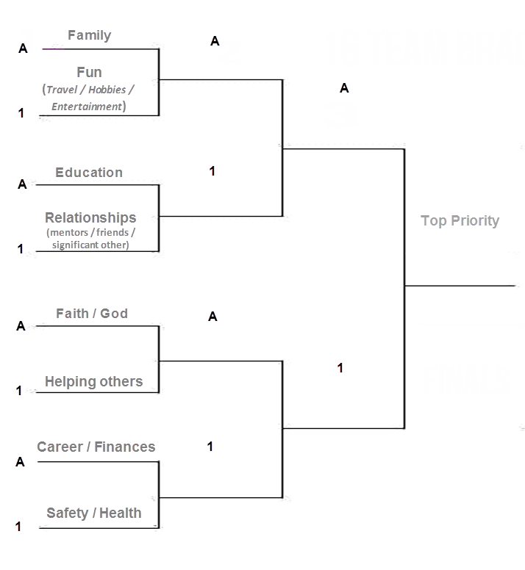

Empty Bracket

