Middle/High School Sunday School Lessons by

rfour.org

Year 1: Session 8 – No Fear
Class 22: Acts 16:16-32 – Paul and Silas sing in prison

CONCEPTS that will be covered in the lesson
- Provide brief background on Paul
- Highlight the parallels between this story and the previous stories (offering healing leads to persecution but the persecution is met with neither a fight or flight response)
- Point out (again) the comparison between the approaches to life being offered: God’s unafraid, healing approach or the controlling, angry, destructive way of the religious and political leaders

Materials needed:
- Nooma Video called “Rhythm” – this video will be shown in its entirety (about 12 minutes long) and must therefore be purchased.
  - Video can be bought and then downloaded here(off-site link): https://flannel.org/products/nooma-rhythm-011 (Download was $1.99 as of Apr 2015)
- Electronics that will show the video
- A way to display the map at end of lesson
- At least one board game of Twister. Depending on size of class, will want to have another version of game for every grouping of four students in class (for example, the day when I taught this lesson, we had 7 students present, so we used two twister games with the “boards” right next to each other)

THE LESSON

OPENING PRAYER

OPENING QUESTION
- For the opening question for today’s class, I [the teacher] will ask the question, and then to give you some time to think of an answer, I will answer first.
- Once I answer the question, we’ll go around the circle.
- When it’s your turn, start with your name and then answer the question to the best of your ability.
- Here’s this week’s question: What’s a favorite song or band of yours right now? (Note to share with class: Honor your classmates’ answers – even if you do not like their answers. Do not disparage their answers whatsoever.)

TRANSITION TO Activity
- The last few classes, we’ve been looking at the effects of Resurrection on the disciples
- In today’s story, though, we’ll be introduced to Paul – who was never a disciple of Ministry Jesus (pre-Resurrection Jesus)
- In fact, Paul was a Pharisee who helped to hunt down and arrest and persecute members of the early church before he had a “Come to (Resurrected) Jesus” transformative experience
- In today’s story, Paul and his traveling partner, Silas, have been arrested while sharing the news and teachings of Jesus.
- And, they are in a pretty bad spot.
- So to start class today, we’re going to play a few rounds of the “board game” of Twister where the name of the game is trying to avoid bad spots and trying to get out of bad spots

Explain (should be self-explanatory) activity of Twister

DO two or three rounds of Twister
Some notes for the teachers: There is a limit of four players per game. So, if there are more than 4 students, you’ll want to try and have more than one Twister game. If this is the case, put the mats side-by-side and encourage players to consider using multiple mats to their advantage. Or, if multiple games are not available, consider a playoff format. Also, depending on numbers, teacher(s) may want to play. Finally some students may not want to play. Honor these desires and invite them to be spinners/callers of moves.

ASK
- What were some of the reasons for why players found themselves in a bad spot/all twisted up in the games? (previous choices, tough spins, choices by other players)
- When players were in a bad spot/all twisted up, what were some of their responses to being in a bad spot (to make loud noises of agony, encourage the spinner to spin faster, fall over, try to push others over, etc)
- When a player was in a bad spot/all twisted up, did the other players try to help that player out at all? (nope)

TELL
- As mentioned earlier, Paul and Silas find themselves in a bad spot in today’s scripture story.
- Before we find out what choices they make and how they respond to being in the bad spot, here’s a very brief summary of who Paul is/was:
  - Paul was a Pharisee at first – he was present at (and approving of) the stoning of Stephen (Stephen was one of the first deacons of the early church)
  - As a Pharisee, he persecuted the leaders of the early church – he traveled far and wide to find them and arrest them
  - After his conversion where he literally “saw the light,” Paul continued traveling far and wide – only this time he did so to share the news and teachings of Jesus with Jews and Gentiles alike.
  - That we know of, Jesus never traveled more than 60 miles from his hometown (as an adult) -- Paul, on the other hand, traveled thousands of miles from his hometown.
  - Here’s a map that shows all the places Paul went (see map at end of lesson)
  - In today’s story, he and Silas are at Philippi (circled on map) and they’ve been arrested for sharing the news and teachings of Jesus (just like the Peter and John were arrested in previous class and just like Jesus was arrested and crucified – the pattern continues)
  - Let’s see what happens – Note that the story is told in the first person, most likely because the author of Acts was actually involved in this story.

READ Acts 16:16-34 (recommend class reads it out loud; one person per verse, including teachers)
16 One day, as we were going to the place of prayer, we met a slave-girl who had a spirit of divination and brought her owners a great deal of money by fortune-telling. 17While she followed Paul and us, she would cry out, ‘These men are slaves of the Most High God, who proclaim to you a way of salvation.’ 18She kept doing this for many days. But Paul, very much annoyed, turned and said to the spirit, ‘I order you in the name of Jesus Christ to come out of her.’ And it came out that very hour.

19 But when her owners saw that their hope of making money was gone, they seized Paul and Silas and dragged them into the market-place before the authorities. 20When they had brought them before the magistrates, they said, ‘These men are disturbing our city; they are Jews 21and are advocating customs that are not lawful for us as Romans to adopt or observe.’ 22The crowd joined in attacking them, and the magistrates had them stripped of their clothing and ordered them to be beaten with rods. 23After they had given them a severe flogging, they threw them into prison and ordered the jailer to keep them securely. 24Following these instructions, he put them in the innermost cell and fastened their feet in the stocks.

25 About midnight Paul and Silas were praying and singing hymns to God, and the prisoners were listening to them. 26Suddenly there was an earthquake, so violent that the foundations of the prison were shaken; and immediately all the doors were opened and everyone’s chains were unfastened. 27When the jailer woke up and saw the prison doors wide open, he drew his sword and was about to kill himself, since he supposed that the prisoners had escaped. 28But Paul shouted in a loud voice, ‘Do not harm yourself, for we are all here.’ 29The jailer called for lights, and rushing in, he fell down trembling before Paul and Silas. 30Then he brought them outside and said, ‘Sirs, what must I do to be saved?’ 31They answered, ‘Believe on the Lord Jesus, and you will be saved, you and your household.’ 32They spoke the word of the Lord to him and to all who were in his house. 33At the same hour of the night he took them and washed their wounds; then he and his entire family were baptized without delay. 34He brought them up into the house and set food before them; and he and his entire household rejoiced that he had become a believer in God.

ASK
- Verse 16, what is wrong with the slave-girl? (has a spirit of fortune telling – **see note at end of lesson about unclean spirits)
- Verse 17, what does the slave-girl keep doing to Paul and Silas? (pronouncing who Paul and company were to everyone around them)
- Verse 18, what does Paul do? (orders the unclean spirit out of the woman)
- Verse 19, what does this mean the girl can no longer do? (make money for her owners)
- Verse 21, are Paul and company accused for doing what they actually did … or something else? (something else)
  - What was the something else? (disturbing our city and advocating customs that are not lawful for Romans)
- Verse 22-24, what then happens to Paul and company? (they are attacked by the crowd, stripped of their clothes, flogged [i.e. whipped or hit with sticks] by the police, then thrown into the innermost prison cell with their feet bound in stocks]
- Note: Pretty rough treatment for healing someone, don’t you think? This is very similar to the leaders planning to kill Jesus after he raised Lazarus from the dead and how the authorities arrest Peter and John after they healed the lame man.
- Verse 25, how do Paul and Silas respond to all of this unfair and harsh treatment? (they pray and sing to God)
- Verse 26, Does it say anywhere in the story that the earthquake that happens is due to Paul and Silas’ prayer and singing or that God caused it (No, not at all)
- Verse 27, what does the jailer think has happened and what is he going to do about it? (he thinks everyone has escaped and so he’s going to kill himself rather than face the punishment [possibly crucifixion] for letting the prisoners escape)
- Verse 28 – If Paul had just kept quiet, then they all could’ve escaped – but instead Paul speaks up and the man keeps his life.
- There are two responses from the jailer. The first response is in verse 29 and 30, what is it? (asks for advice and how he can be saved – we’ll talk about that in a little bit)
- The second response by the jailer is in verses 33 and 34 – what does he do for Paul and Silas at that point? (Takes them home, cleans their wounds, and feeds them)
- So what do you think, was it a good choice by Paul to speak up when the jailer was going to kill himself instead of trying to escape?

TELL
- First and foremost this story reminds us, yet again, that God’s way of life (this time as portrayed by Paul) leads to more life: Paul heals the girl, sings in prison, and saves the jailer’s life.
- Compare this to the authority’s way of life: They falsely accuse Paul and Silas, punish them without a trial, and then throw Paul and Silas in prison without a trial
- Which way of life is more attractive to you?
- In verse 29 and 30, we see that the way of Paul and Silas is the more attractive way to the jailer. By asking how he can be saved, he’s basically saying he wants to switch teams – he now wants to be on Team Disciples.
- He wants to know how to live the way like Paul and Silas that leads to more life.
- By now, we should be used to this, though, right? Whether it’s Jesus, the disciples, or Paul, it’s the same story: Teach, heal, get punished, but keep sharing God’s life with others and some of those others are going to sign up and join along.
- Another, but similar, way to think about this story is that there are two songs being sung.
- The authorities are singing one type of song and Paul and Silas are singing another type of song
- Which song does the jailer decide to sing along with? What song might you want to sing along with? [To the teacher(s): These are mostly rhetorical questions, by the way]

TRANSITION TO VIDEO CLIP
- Those last two (and rhetorical) questions also help us to transition to our video for today
- The clip is a little bit different than usual – instead of a brief scene that mirrors an idea in the story we read, the clip for today is 10 minutes long and has a start, middle and end.
- The guy who does the talking is Rob Bell, and he’s says some things about music and God that I think fit well with this story.
- Let’s see what he has to say

WATCH Nooma Rhythm VIDEO

TELL
- Rob Bell says, “When I think of God, I hear a song…And so, Jesus came to show us how to live in tune with the song. How Jesus is, is how God is like.”
- Paul, like Jesus, lived in tune with “the song,” and because he stayed in tune, even when it would’ve been easy to get out-of-tune, he shared the song.
- And, because a good song is catchy – we’re still hearing it today
- The good news is that we’re invited to sing along.

CLOSING PRAYER

**A note about unclean spirits: The focus of the lesson is meant to zero-in on how what Paul and Silas do and how it is similar to the other stories from previous lessons that the students have been reading/paying attention to and not about unclean spirits, which could be its own, long lesson. In case the students do ask about what an unclean spirit is, here’s something to consider saying in response to their questions:

First, let’s be clear about this: The unclean spirit is 'bad' for the slave girl, but that doesn't mean there aren’t benefits that come along with it.

A helpful way to think about unclean spirits (which CAN be translated from Hebrew or Greek as "dirty breath") is to think of smoking – smoking is bad for us, but folks do it because of what the nicotine offers (buzz, weight loss, calming effects even though it’s an upper) and the less so, now, coolness/peer factor. And, of course, there's an entire industry that doesn't want smokers to quit smoking because that affects the companies' bottom lines and people's jobs, etc. It's pretty analogous to what we see happening in this story: There's someone with a beneficial "habit," but that habit is also unhealthy. Once the unhealthy habit is broken (with help from others), the ones who were financially benefiting get upset. The part that isn't analogous is the "origin" stories between an unclean spirit vs smoking. But this story isn't so much about origins as to why healing is difficult in general / why people oppose healing / how that opposition can initially suppress God's better way, etc.

---Map of Paul’s travels is on the next page---
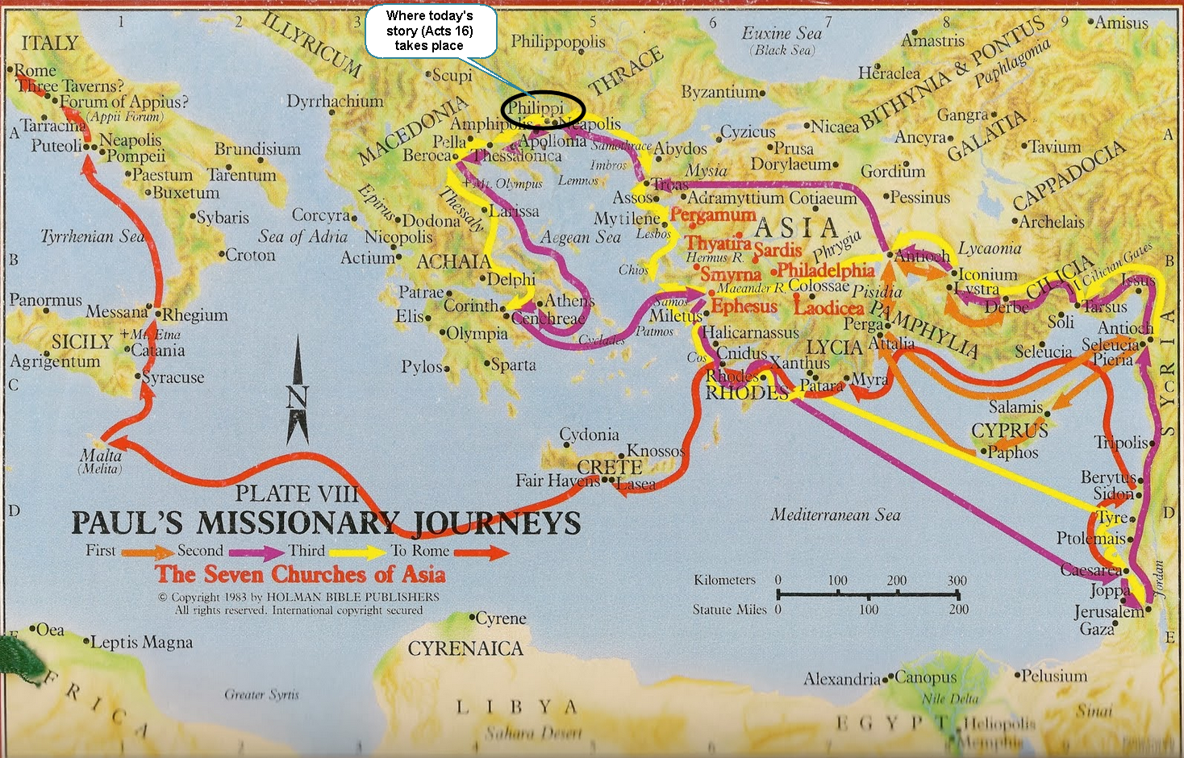

From: http://relevancy22.blogspot.com/2014/02/pauls-missionary-journeys-maps-and.html

