Middle/High School Sunday School Lessons by

rfour.org

Year 4: Session 1 – Putting God First
Class 1: 2 Samuel 6:1-5; 12-23 – King David Dances

CONCEPTS that will be covered in the lesson
- Because this is the first lesson of the year, explanations of the different components of the lesson and the reasons for them are embedded in the lesson (for teachers and students alike)
- Provide brief background about King David and the Ark of the Covenant
- Explore / discuss the power of the feeling of embarrassment
- Look at how David isn’t worried about being embarrassed by his expression of feelings about and for God because he trusts that he won’t lose God’s love.
- Tie this freedom that comes with belonging and love (instead of peer pressure to fit in) to the class, teachers, and upcoming school year

Materials needed:
- Video clip (available on rfour.org) from 10 Things I Hate About You
- Electronics that show the video clip
- Cut out the list of words for charades (at end of lesson) and have a bowl or hat to put the cut out words into
- Optional: A way to display the picture of the ark located at end of this lesson

THE LESSON

OPENING PRAYER

OPENING QUESTION
- This is our first class of a new year
- And what you’ll start to see is that the class has a certain rhythm to it. We do a lot of the same things every class. One of the things we do every class is ask and answer an opening question at the beginning of class – because it helps us 1. Learn more about each other and 2. Helps “warm us up” for some of the ideas in the upcoming lesson. So we’re going to do that now.
- I [the teacher] will ask the question and then to give you some time to think of an answer, I will answer first.
- Once I answer the question, we’ll go around the circle and each of us will answer.
- When it’s your turn, start with your name and then answer the question to the best of your ability.
- Here’s this week’s question: What’s something that a family member (WHO IS NOT IN THE ROOM) has done or still does that embarrasses you? [Note to teachers: When you are answering the question, it’ll be better to use a current day example, not one from the past]

(Optional) INTRODUCING THE NEW YEAR
It’s the start of a new school year and there are a few things that we need to cover -- (share your expectations & schedule for the year and whatever else you feel is pertinent)

TRANSITION to MOVIE CLIP
- Our lessons this year will be organized by sessions.
- A session will consist of 3 classes grouped together by a shared idea found in the three Bible stories that we’ll be reading during those 3 classes in that one session.
- So our first session is going to be about looking at characters in Bible stories who “Put God First.” And then our second session will be looking at characters in Bible stories who “Put God Not-First”
- So to get started with today’s lesson, the next thing we’re going to do is watch a movie clip.
- We usually watch a movie clip every class.
- The movie clip is meant to help us see how at least one of the themes that we’ll see in the Bible story (that we’ll read in class) is still alive and well in the stories we pay attention to in the here-and-now.
- Sometimes we’ll watch the clip after the opening question, sometimes near the end of class.
- Today, obviously, we’re going to watch the movie clip after the opening question.
- Today’s movie clip is from the movie, “10 Things I Hate About You.”
- The movie is from the late 90s and this particular scene is meant to be a little bit funny, but it is also a little cringe-inducing as a high school boy very publicly expresses his feelings for a high school girl. (Note: They DO have a little bit of a history – so it’s not like a complete stranger is singing a song to a long distance crush. They at least know each other)
- (if needed: Yes, that IS Heath Ledger who later on went to play the Joker in the Batman movie, “The Dark Knight”)
- Let’s see what happens

WATCH MOVIE CLIP

ASK
- How did the boy express his feelings for the girl? (by singing them)
- Do you think he put some planning into it? (a little bit, especially since he paid the drum major to have the marching band played along)
- Could you ever see yourself doing what the boy character did?
- Do you think the girl character appreciated the display of affection or not? (kind of hard to tell from the clip – she doesn’t seem too embarrassed or upset though)
- If someone did that for/to you, what do you think your response would be?

TELL
- How we appear to other people – is kind of a big deal
- We want to be liked and we want to belong, so there’s a strong pressure to be like everyone else and fit in.
- Because if we stick out of the group too much then maybe we won’t be allowed back in or maybe it’ll just be obvious to everyone that we never belonged at all.
- Which is why in the movie clip, the risk that the Heath Ledger character took to stand out so far from everyone else can feel a little uncomfortable to watch
- In today’s scripture story, a similar scene takes place.
- Except, instead of a boy singing to a girl, a king – King David – is going to dance in front of God.
- But, one of his wives wants King David to behave more like a king and less like Heath Ledger.
- But before we see what happens in the story, here’s some background on what we’re about to read:
  - King David lived around 1000 BC. He was the second king of Israel.
  - The “ark of the Lord” is not like Noah’s ark. It is not a boat. Instead, it’s what the Israelites used to carry around the 10 Commandments when they were in the wilderness (we’ll talk about some of those stories later in the year).
  - To see one artist’s rendition of what the ark may have looked like, here’s a picture (show the picture located at the end of the lesson)
  - The “ark of the Lord” (also known as Ark of the Covenant) was stolen a few times, moved around a few times and even forgotten for awhile.
  - In today’s story, due to King David’s desire to show God is at the center of Israel, the ark was brought to the capital of Israel to stay.
- Let’s see what happens
- Note about the year: Every class we do will have a Bible story in it. And we will read it just like we’re going to read it now: Outloud, one student per verse, from the Bibles in the classroom.

READ 2 Samuel 6:1-5, 14-23 (recommend class reads it out loud; one person per verse)
1 King David gathered the best troops in all of Israel - thirty divisions of them. 2 Together with his soldiers, David headed for Balla to recover the ark of the Lord. 3 They placed the ark on a brand-new oxcart and removed it from Abe’s house on the hill. Use and Ohio, Abe’s sons, were driving the new cart 4 loaded with the ark, Ohio in the lead and Use alongside. 5 David and the whole company of Israel were in the parade, singing at the top of their lungs and playing mandolins, harps, tambourines, castanets, and cymbals.

14 David, ceremonially dressed in priest's linen, danced with great abandon before God. 15 So David and all the house of Israel brought up the ark of the Lord with shouting, and with the sound of the trumpet. 16 As the ark of the Lord came into the city of David (aka Jerusalem), Michal, one of David’s wives, and the daughter of Saul (David’s predecessor) looked out of the window, and saw King David leaping and dancing before the Lord; and she despised him in her heart. 17 They brought in the ark of the Lord, and set it in its place, inside the tent that David had pitched for it; and David offered burnt offerings and offerings of well-being before the Lord. 18 When David had finished offering the burnt offerings and the offerings of well-being, he blessed the people in the name of the Lord of hosts, 19 and distributed food among all the people, the whole multitude of Israel, both men and women, to each a cake of bread, a portion of meat, and a cake of raisins. Then all the people went back to their homes.

20 David returned to bless his household. But Michal the daughter of Saul came out to meet David, and said sarcastically, "How the king of Israel honored himself today, uncovering himself today before the eyes of his servants' maids, as any vulgar fellow might shamelessly uncover himself!" 21 David said to Michal, "It was before the LORD that I danced. The LORD who chose me in place of your father and all his household and appointed me as prince over Israel. 22 I will make myself yet more contemptible than this, and I will be abased in my own eyes before the LORD; but there are others who worship the LORD and by them I shall be held in honor.”
ASK
- Is there anything you find interesting or weird about this story? [to teachers: You don’t necessarily need to answer what they notice or have questions about – sometimes just agree with a, “yep, that’s interesting” or a, “Yeah, I find that to be weird, too” works]
- Verse 1-5 – Bringing the ark to Jerusalem seems to be a big deal! What clues/hints in these first few verses tell us that this is a big deal?
- Verse 14 – What is David doing in this verse? (dancing like a crazy fool!)
- Why do you think he is doing this? (because this is a big deal and he’s excited about it and celebrating!)
- Who does not like David’s dancing? (one of his wives, Michal)
- Verse 17-19 – What other ways do King David and the people of Israel celebrate the bringing of the ark to Jerusalem? (by giving offerings to God and distributing food among all the people)
- Do you think the people of Israel minded David’s dancing? (hard to tell, probably not as much as Michal, though)
- Verse 20 – What does Michal tell David is the problem with his actions? (basically that he was embarrassing. Note: Due to the description earlier in the passage vs what Michal is saying, it’s tough to know if David was actually dancing naked or not – but if he was naked that probably WOULD be embarrassing – at least a little bit -- don’t you think?).
- What do you think, does Michal have a point?
- Verse 21 – Who does David say he was dancing for/before? (God)
- So…do you think God had the same reaction as Michelle did about David’s dancing?
- Why?
- Verse 22 – Does David say he’ll stop dancing? (Nope, in fact, he’ll do things for God that will be even more embarrassing, he says)

TELL
- First – a little bit more about the Ark
  - The ark is where the Israelites’ covenant with God, aka the 10 commandments, were stored.
  - This meant the Israelites thought of the Ark as their symbolic home for God. They knew that the Ark was not where God actually lived, but it was definitely a focus point and reminder that God was with them.
  - So to bring God’s symbolic home and their covenant with God to the center/capital of their country was a potent symbol and message of putting God at the center of their lives
  - Basically, this is a story where the people of Israel are saying, “God is to be at the center of our country.”
  - And, they think this is a good thing -- thus, the big party.
- Second – King David’s dancing tells us that he’s NOT trying to impress anyone. Because Michal is right – his dancing is NOT kingly behavior. Instead, what he is doing is expressing/conveying his feelings for God, much like how the Heath Ledger character was expressing his feelings for the Julia Styles character in the movie clip we watched.
- Third – at least in this story, King David understands his position in life. We know this 1. By the dancing, but then 2. By the title he gives himself in verse 21 – the title of “Prince.” David recognizes that God is first – that God is king and that he, David, rules under God’s rule.
- And fourth – David cares more about what is important to and about God than David cares about what his citizens and even his wife/wives think. David is putting God first and it affects his actions.
  - Note, even if his actions are embarrassing, his actions are generous to the people of Israel – it was quite the party!.

TELL – Context
- So what does this story have to do with us?
- Well, basically, the story is a reminder that should we express love or appreciation or loyalty to God – then we will probably experience being put on the outside of what SOME people think is cool or acceptable behavior.
- But, this story is ALSO a reminder that we, like David, do not have to be cool and awesome and well-put together to be loved by God and to belong to God’s family.
- As a way to start the year – we, the teachers, want to be very clear that we welcome you and love you (even if we don’t know you very well, yet) and we are very happy to have you here regardless of how you fit in or don’t fit in at school, with friends, at home, etc.
  - This means that we don’t have to worry about being perfect and well-put together when we’re here.
  - We don’t have to worry about always saying the right thing or wearing the right clothes
    - Now, this doesn’t mean that we can just do whatever we want while we are here – because there are certain ways we need to work together to make the class work best for everyone, but it does mean that we want you to be know that it’s ok for you to be you when you’re here.
- To wrap up today’s class and help highlight this point that we don’t need to always be perfect, let’s do the following activity

TRANSITION TO ACTIVITY
- We typically have an activity where we get to do something as a class that helps us think about one of the ideas that we see in the Bible story that we read.
- Usually the activity happens near the end of class.
- And that’s what we’re going to do now
- So, we’re going to get into two teams (two teams that are equal in number)
- A teacher will be on each team.
- The first team up will have their teacher come up front
- The teacher will pull a slip of paper with a word on it from this bowl/hat/cup
- The teacher will then act out the word without talking or moving their lips.
- The first team must then try to correctly guess what is being acted out in 30 seconds or less.
- The team may make as many guesses as you want.
- If you guess correctly, you get 2 points.
- If, after 30 seconds, the first team doesn’t guess correctly, then other team gets ONE official guess.
- If guessed correctly, the 2nd team gets 1 point.
- Play then goes to the other team, where their teacher teammate goes first.
- The person who is to act out the clue can rotate – you don’t HAVE to be the charades person but we really hope that you give it a try. If no one wants to, then the teacher will keep be the charades person. But we hope you give it a try.
- Again, the person acting out the clue may not say ANYTHING or make ANY noises…not even mouthing of words

DO ACTIVITY of charades (see list of words at bottom of this page)

TELL
- If we trust that we are loved, then we can live into the freedom that comes with not being afraid of losing that love.
- So not only did David get to dance in the middle of the street because he trusted that God loved him, but we also get to play charades in class and all sorts of other things because we can trust that God loves us and that as a family created and built on God’s love, we don’t need to be perfect to belong to it.
- It’s going to be a good year and we’re very happy to have you here and to be part of the class!
- See you next week!

CLOSING PRAYER

List of words to print out and cut out for charades

Hide & seek
Diaper
Taking a shower
Artist
Roller coaster
Swing
Ballerina
Worm
Slow motion
Magnifying glass
Santa Claus
Pogo stick
Skunk
Snowball fight

Kite
Finger-painting
Weight-lifter
Dentist
Tarzan
Pin the tail on the donkey
Hula dancer
Cotton candy
Earthquake
Vampire
Bumper cars
Home Run
Tug of war
Roller blading

Make-up
Grocery Shopping
Harder ones:
Setting an alarm clock
Watching a football game
Getting your nose pierced
Baby sitting
Clothes pin
Electric fan
Snow
Spaghetti
Sprinkler
Suspicious
Celebration

One example of what the Ark of the Lord may have looked like

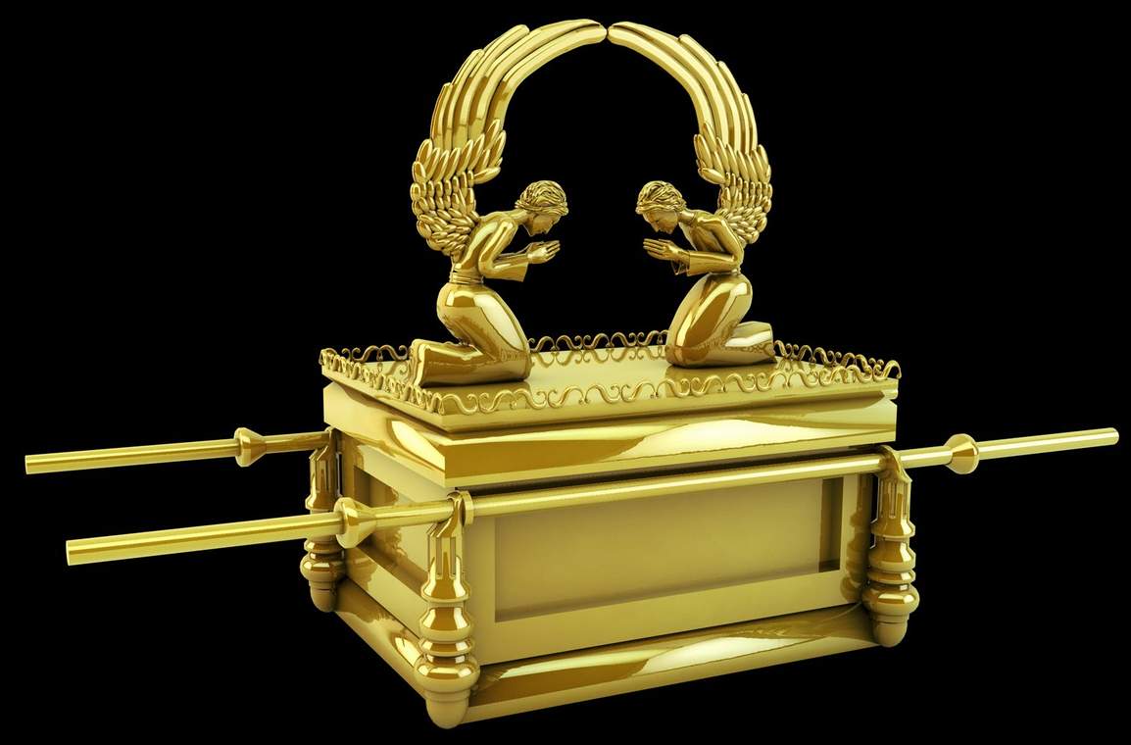

Some more Ark info:
God made a covenant/agreement with the people of Israel at Mount Sinai after leading them out of Egypt. This is when God gave Moses the Ten Commandments. God also gave Moses instructions to make a chest or box of acacia wood with poles in which to store these Ten Commandments (which were written on two stone tablets). The ark was to be set behind the inner curtain in the most holy place inside the sacred tent (Exod 26:34; 40:3,21). God would meet with the people by the sacred chest and tell them what to do (Exod 25:10-22). The sacred chest was called “Ark of the Covenant” because it held the tablets of the Ten Commandments and symbolized the presence of God.

The Levities (the priests of Israel) carried the Ark by the poles on their shoulders (Deut 10:8). It went with the people during their desert wanderings (Num 10:17,33). It was carried with them into battle (Joshua 6), was captured by the Philistines (1 Samuel 4), and was returned to Kiriath-Jearim where it stayed for twenty years (1Sam 5:1-7:2). David had it brought to Jerusalem and set under a tent (2 Sam 6:1-19 - which we just read). Solomon (the king after David) moved it to the newly built temple (1 Kgs 8:1-21).

The Ark of the Covenant was no longer heard of after the fall of Jerusalem and the destruction of the first temple in 587 B.C.

