Middle/High School Sunday School Lessons by

rfour.org

Year 2: Session 2 – Stories About Chaos
Class 5: John 2:1-10 – Water to Wine

CONCEPTS that will be covered in the lesson
- Read the story of Jesus changing water to wine
- Continue identifying the symbols of chaos in the scripture stories
- Discuss how water to wine is partly about potable water (that is, a story of transforming a chaos-giving moment to a life-giving moment)
Materials needed:
- NOTE: This lesson makes a number of references to the stories and lessons from the previous session (Session 1: God and Communication)
- Movie clip (available on rfour.org) from The Code
- Electronics that show the video clip
- For the activity:
  - A way to write down and display answers from the opening question
  - A way to then edit the answers from the opening question
  - A way to display the example pictures located at end of lesson (print out or laptop)

THE LESSON
OPENING PRAYER
OPENING QUESTION
- One of the things we do every class is ask and answer the opening question at the beginning of class – because it helps us 1. Learn more about each other and 2. Helps “warm us up” for some of the ideas in the upcoming lesson. So we’re going to do that now.
- So here’s the opening question for today’s class. I [the teacher] will ask the question and then to give you some time to think of an answer, I will answer first.
- Once I answer the question, we’ll go around the circle and each of us will answer.
- When it’s your turn, start with your name and then answer the question to the best of your ability.
- Here’s this week’s question: What is one of your favorite movies and one of your least favorite movies? Note: we’re going to record your answers because we’ll then use our answers in today’s activity

TRANSITION TO ACTIVITY
- In our previous session, we read 3 stories in which we saw demonstrations of the power of language.

- Then, in our last class, we started a new session where the stories we’ll discuss include a chaotic situation in them.
- Just as a quick reminder from last class that chaos is when
  - Things that were ordered become disordered
  - When random, unexpected things happen, like luck
  - And just like luck, chaos can be good or bad (good luck vs bad luck)
  - But, overall, to always be in a chaotic situation creates stress in us that wears us down.
  - Eventually, chaos overwhelms us
  - At that point, we start to make mistakes from distraction and overload and weariness
- So how are we to respond to chaotic situations? That’s the question that we are looking to answer in each of the stories that we’re reading this session.
- In the first story we read, we saw Jesus calm the storm
- In that story, we first saw a chaotic situation (the storm) and we then saw Jesus speak into the chaotic situation and transform that chaotic situation into a calm situation.
- We discussed how the power of language (from first session), was partly what we saw happen when Jesus told the storm to be still.
- In today’s story, we will see a similar pattern.
- We will see Jesus speak into a chaotic situation and by speaking, he (with help this time) will transform a chaotic thing into a far less chaotic thing.
- To help us start thinking about how adding or removing things with speech can greatly transform one thing into another thing, let’s do the following activity.

EXPLAIN ACTIVITY
- I have up here (on computer / tv screen / notepad) the movie names you mentioned in your opening question
- What we’re going to do as a class is think of different ways we could remove just one letter from the movie title that would then completely change what the movie was about.
- For example – let’s look at some of these following examples from the author of “movie title typos”
- [show picture examples at end of lesson]
- Remember, we’re not just changing the movie title – we’re changing the movie plot too! Feel free to help each other out with the plot change once one of you shares a one-letter change to one of the movie titles up here.
- Alright, let’s get started!

DO ACTIVITY

TRANSITION TO SCRIPTURE
- Well that was fun! Y’all are very clever (and funny)! Thank you for doing that.
- So, today’s scripture story is one that you’ve probably heard of before – it’s the one where Jesus turns water into wine.
- One of the interesting things about this story (I think) is that Jesus has not really started his ministry yet – as we’ll hear him say, except he does have disciples with him.
- Which is why it’s probably a good thing (or not – you decide!) that his mother is there
- Let’s find out what she does in the story and then discuss (among other things) why she may have helped Jesus with transforming a potentially chaotic situation into a non-chaotic situation.

READ John 2:1-10 (recommendation: Have class read it aloud; one person per verse)
2:1 On the third day there was a wedding in Cana of Galilee, and the mother of Jesus was there. 2Jesus and his disciples had also been invited to the wedding. 3When the wine gave out, the mother of Jesus said to him, “They have no wine.” 4And Jesus said to her, “Woman, what concern is that to you and to me? My hour has not yet come.” 5His mother said to the servants, “Do whatever he tells you.” 6Now standing there were six stone water jars for the Jewish rites of purification, each holding twenty or thirty gallons. 7Jesus said to them, “Fill the jars with water.” And they filled them up to the brim. 8He said to them, “Now draw some out, and take it to the chief steward.” So they took it. 9When the steward tasted the water that had become wine, and did not know where it came from (though the servants who had drawn the water knew), the steward called the bridegroom 10and said to him, “Everyone serves the good wine first, and then the inferior wine after the guests have become drunk. But you have kept the good wine until now.”

ASK
- Is there anything you find interesting or weird about this story? [to teachers: You don’t necessarily need to answer what they notice or have questions about – sometimes just agree with a, “yep, that’s interesting” or a, “Yeah, I find that to be weird, too” works]
- In verse 1, what is Jesus’ mom attending? (a wedding)
- Who else was invited to the wedding? (Jesus)
- Did he attend? (yes)
  - Something to remember about Jesus: He was not a party-pooper
- What problem arises in verse 3? (the party runs out of wine)
- In verse 4, does Jesus think this is his problem to solve? (no)
- But does his mother think he can solve it!? (yes)
- In verse 5 – What does Jesus’ mother do? (tells the servants to do whatever Jesus tells them to do)
- In verse 6 – What are the water jars for? (Jewish rite of purification)
- Verse 7 – Has Jesus seemed to have changed his mind about solving the wine issue? (well, it does seem like he has a plan at this point)
- In verse 7 and 8, do the servants have any idea about what Jesus is doing (nope)
- Do they do what he says anyways? (yes)
- Verse 8-10: What is happening in these two verses? (there is a slow realization that there is wine again, that it is really good wine, and that there is now a LOT of it)

TELL
- This situation probably does not seem too chaotic to us. A party running out of wine probably doesn’t seem like a big deal, right?
- But there are some cultural differences that we’re probably not catching right away:
  - A wedding party in Jesus’ time did not just last for a few hours like it does now.
    - A wedding party could last as long as a week
    - And people would travel from very far away and then be housed where the party was happening
  - Furthermore, wine wasn’t just for people who liked to drink alcohol. Alcohol in water (aka wine) in Jesus’ time was how you made the water safe to drink
  - Basically, there were things in the water (what we understand now to be “bacteria”) that made a life-giving thing (water) a sick-inducing thing.
  - In fact, if you drink unsafe water or water with bacteria in it that your body is not used to, it can create a pretty chaotic situation inside of you
  - So, by adding alcohol to the water, the people in Jesus’ time were able to kill off the bacteria in the water and make the water safer to drink.
  - In other words, by changing water to wine, Jesus wasn’t (just) providing a good time to all; Jesus provided safe, potable drinking water for an entire set of people.
- Though this story is much less chaotic (in the moment) than last lesson’s story, the way Jesus deals with it is the same. He speaks into it.
- In the storm story, he spoke directly to the storm – telling it to be still. And it listened, just like creation listened to God in the creation story.
- In today’s story, Jesus doesn’t speak to the water, but Jesus does speak to the people.
- And the people listened – mostly because Jesus’ mother said, “Or else!” …but still – they did listen and act on Jesus words.
- In response to Jesus words, a chaotic thing (not-safe water) was transformed into life-giving thing (safe water/wine).
- This is sort of like when we removed one letter in our opening activity from a movie and thereby transformed it into a (potentially) better movie.
- OK, maybe that’s a reach, but, in both stories, Jesus speaks. In both stories, there is listening. And in both stories, the chaos of the water is transformed due to the spoken words.

TRANSITION TO MOVIE CLIP
- To help us think about how listening and responding to what someone else says can be beneficial activity for both ourselves and others, let’s watch the following video clip from the movie The Code.
- In it, two characters are trying to break into a vault (I have no idea why)
- One character (played by Morgan Freeman) is able to see the alarm lasers and tries to guide the other character – who can’t see the lasers -- through the lasers
- Let’s see how it goes for them

WATCH MOVIE CLIP

ASK
- What did the Morgan Freeman character have that the other character did not have? (a device to see the lasers with)
- How did the Morgan Freeman character use this device? (he watched it and then gave instructions to the other man)
- Did the other man listen to Freeman’s instructions? (yes)
- Were there some instances where Freeman’s instructions weren’t necessarily acted upon fast enough / correct enough? (definitely some close calls)
- Did the other man ever argue with Freeman’s instructions? (nope)
- What was the result of Freeman’s instructions and the actions of the other man based on the instructions he heard? (they both got to the other side of the room / hallway)

TELL
- In today’s story, there are things that Jesus sees and understands that other people are not seeing and understanding – just like the Morgan Freeman character
- But, because people listened to Jesus (thanks to mom!) -- just like the other man listened to Morgan Freeman -- then the water turned from a chaotic thing into a life-giving thing and was beneficial to everyone there – including Jesus.
- I think this is a good reminder to us – when things get worrisome, that’s a good reminder to ask God to help us be able to see and understand the situation better so that we can share words that will help transform the situation from a chaotic one into a life-giving one.
- And that’s the good news for today.

CLOSING PRAYER

See next pages for examples of removing one letter from a movie title
(pictures from http://imgur.com/a/f2wSg)

Original Title: Jurassic Park
New Title: Jurassic Par

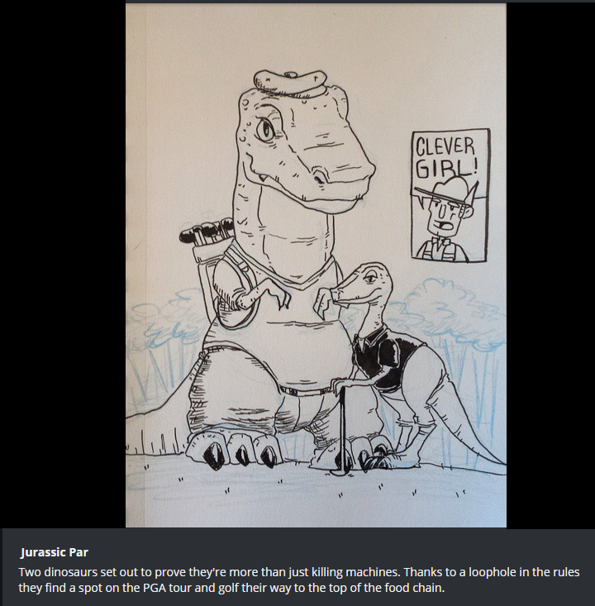

Original title: Robocop
New Title: Obocop

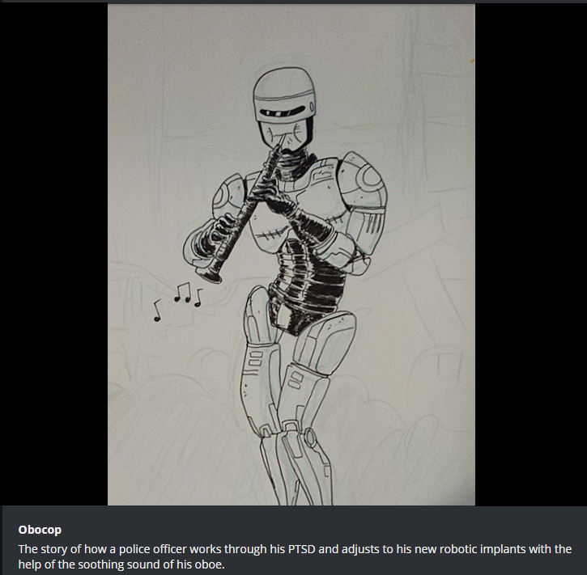

Original Title: Harry Potter
New Title: Harry Otter

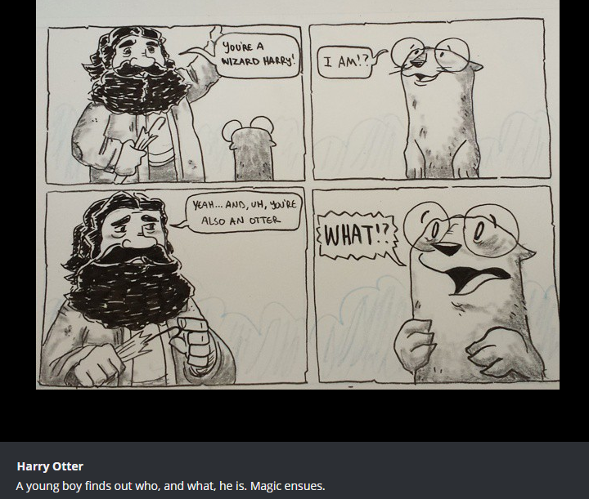

Original title: Lord of the Rings
New Title: Lord of the Rigs

